**SECURIN DOCUMENTATION**

**JEETHESH MSK  
22011101061  
AI&DS-A**

**Tech Stack used:**   
**Mysql**

**FLASK**

**REACT**

**NODE**

**JSONIFY**

**INRTODUCTION  
  
JSON file containing recipes, I have parsed the data, stored it in a database, and developed an API to expose this data. The API should allows pagination, sorting, and searching the recipe records based on various filters.**

**API Endpoint 1: Get All Recipes**

**API Endpoint 2: Search Recipes**

**A simple and elegant webpage was made using react.**

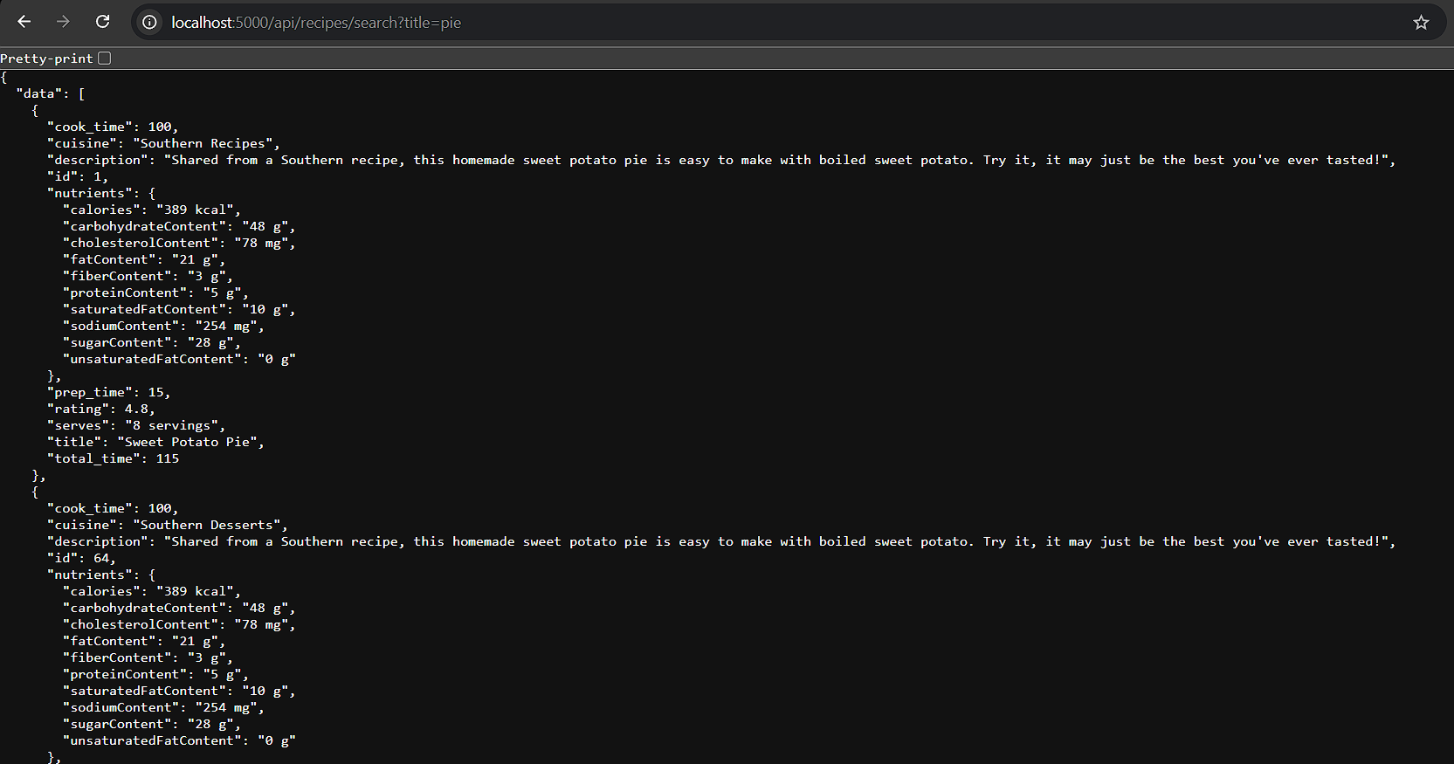**BACKEND: :2 ENDPOINTS**

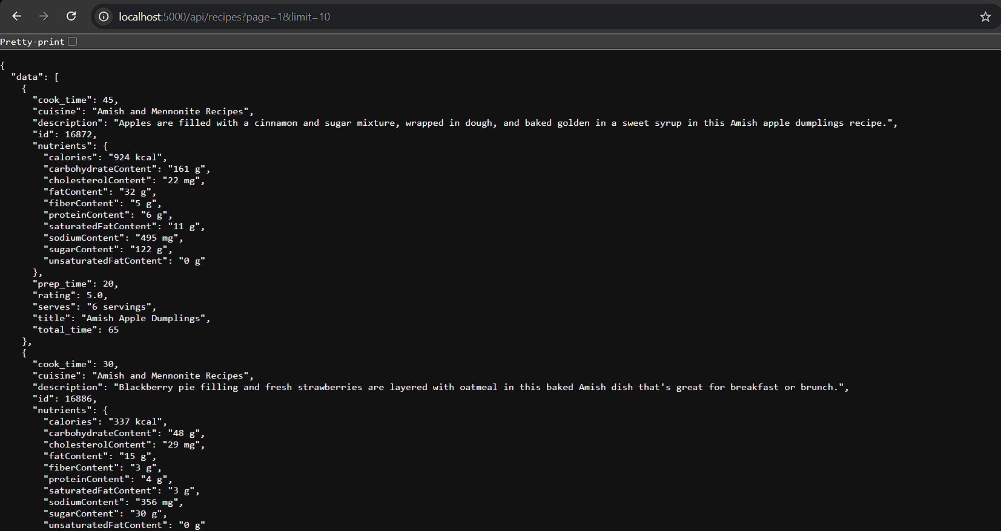

**FRONTEND:**